This HW assumes that the model is x = mass and y = tcell volume.

Based on the average stone mass in grams carried by each black wheatear, along with t-cell response measurements, we are interested in investigating an association between strength, our explanatory variable, and health, our response variable.

1. We initially investigate the relationship visually, which shows a positive relationship between mass and tcell response:

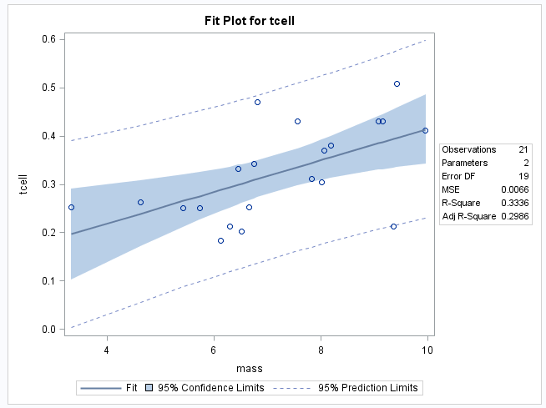

1. Based on hypothesis tests for the y-intercept and slope, we have determined that our intercept is not significantly different from zero (p = 0.28) and the slope is significant at p < .05. Based on this evidence, we assume that at a mass of zero, the tcell count is not significantly different from zero. Realistically, tcell counts would need a baseline value or we could consider the subject birds deceased, therefore we utilize the intercept:

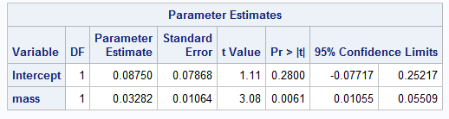

1. Using the data in ii show all 6 steps of each hypothesis test.

Test for intercept:



Based on a p value of 0.28, we fail to reject the null hypothesis that the intercept is significantly different from zero.

The intercept of 0.0875 is not different from zero based on a hypothesis test. Therefore, we should assume the model’s intercept begins at zero. However, a t cell count of zero is not realistic in this model as a bird would be considered deceased, therefore we go forward with the intercept given.

Test for slope:



Based on a significant p value <0.05, we reject the null hypothesis that the slope is equal to zero.

The slope is different from zero based on a hypothesis test. Therefore, we assume the rate of change per kg of mass is 0.03282.

d. The regression equation.



1. Interpretation of the slope and intercept in the model (regression equation.)

At 0 mass the t -cell count (mm) of the birds is assumed to be 0.0875. For each average gram of stone carried (unit increase), the bird’s t-cell volume predicted increases by 0.0328.

1. Pick a stone mass and find and interpret the 95% confidence interval for the mean t-cell response conditional on that mass.





g. For that stone mass, find and interpret the 95% prediction interval for the predicted t-cell response given that mass.







h. Using the graphical method, find and interpret the calibration intervals for the t-cell response of 0.3. (Both for mean t-cell response and for a single t-cell response.



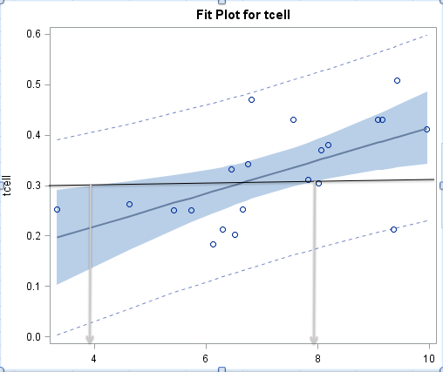

Our y value used to predict x does not intersect the prediction intervals, indicating the calibration interval for individual values of x based on y have a very wide prediction interval. In order to determine this interval, we will calculate it directly.

i. Find the same calibration intervals analytically using the SE equations given in class and in the book (Version 3 page 194).

Calibration Interval for the mean:



Calibration Interval for a single value:



j. A scatterplot of residuals.

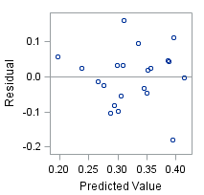

k. A histogram of residuals with normal distribution superimposed.

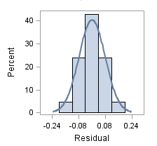

2. Find Figure 1 in this article, and copy this scatterplot into your report. Compare it to your scatterplot in part (a) of the previous problem.

|  |  |
| --- | --- |
| Macintosh HD:Users:patrickcorynichols:Desktop:Screen Shot 2015-07-15 at 9.14.33 PM.png | Macintosh HD:Users:patrickcorynichols:Desktop:Screen Shot 2015-07-13 at 12.29.12 PM.png |

In our example, t cell is predicted by mass and t cell is on the y axis. In the article, mass is on the y axis. Both scatter plots show a definite linear relationship. The article’s regression equation predicts the mass from the t cell response, whereas our model predicts the t cell response from the mass carried.

SAS Code:

**data** birds;

infile '\\Client\C$\Users\PatrickCoryNichols\Desktop\ex0727.csv' FIRSTOBS = **2** DLM = ',';

INPUT mass tcell;

logtcell = log(tcell);

logmass = log(mass);

**RUN**;

**PROC** **PRINT** data = birds;

**RUN**;

**PROC** **GPLOT** data = birds;

PLOT tcell*mass;

SYMBOL1 V = Dot C = BLACK I= RL L =**1**;

**RUN**;

**QUIT**;

**PROC** **REG** data = birds;

MODEL mass = tcell /clb clm cli;

**RUN**;

**QUIT**;

**PROC** **means** data = birds;

**RUN**;